**Project X – HIGH LEVEL DESIGN**

Group Name: **TEAM C**

Members:

* Kissy Faith M. Candia
* Bjor Dimsey Gofredo
* Francis Lloyd Catog

1. **Overview**

Project X is a mobile-based attendance system that utilizes QR code scanning to enable secure, efficient, and real-time attendance tracking. It supports three user roles: Administrator, Instructor, and Student. The system provides QR generation, student check-in, schedule management, and attendance reporting through a modern mobile app.

|  |  |
| --- | --- |
| User Role | Key Function |
| Administrator | Manages system users, courses, and audits. |
| Instructor | Generates session QR codes and views reports. |
| Student | Checks in by scanning class QR codes. |

1. **Key Modules**

|  |  |  |
| --- | --- | --- |
| Module | Description | Tech Stack |
| Authentication | JWT-based role access control | Node.js, Bcrypt |
| QR Generation | Time-bound codes per session | QR-code library |
| Attendance Scanning | Real-time validation and logging | Expo Camera |
| Reporting | CSV exports with filters | React Native PDFKit |

1. **Technology Stack**

|  |  |
| --- | --- |
| Layer | Technology |
| Frontend | **React Native, Expo** |
| Backend | **Node.js, Express** |
| Database | **MongoDB Atlas** |
| Security | **JWT, Bycrypt, Rate Limiting** |

1. **System Architecture**

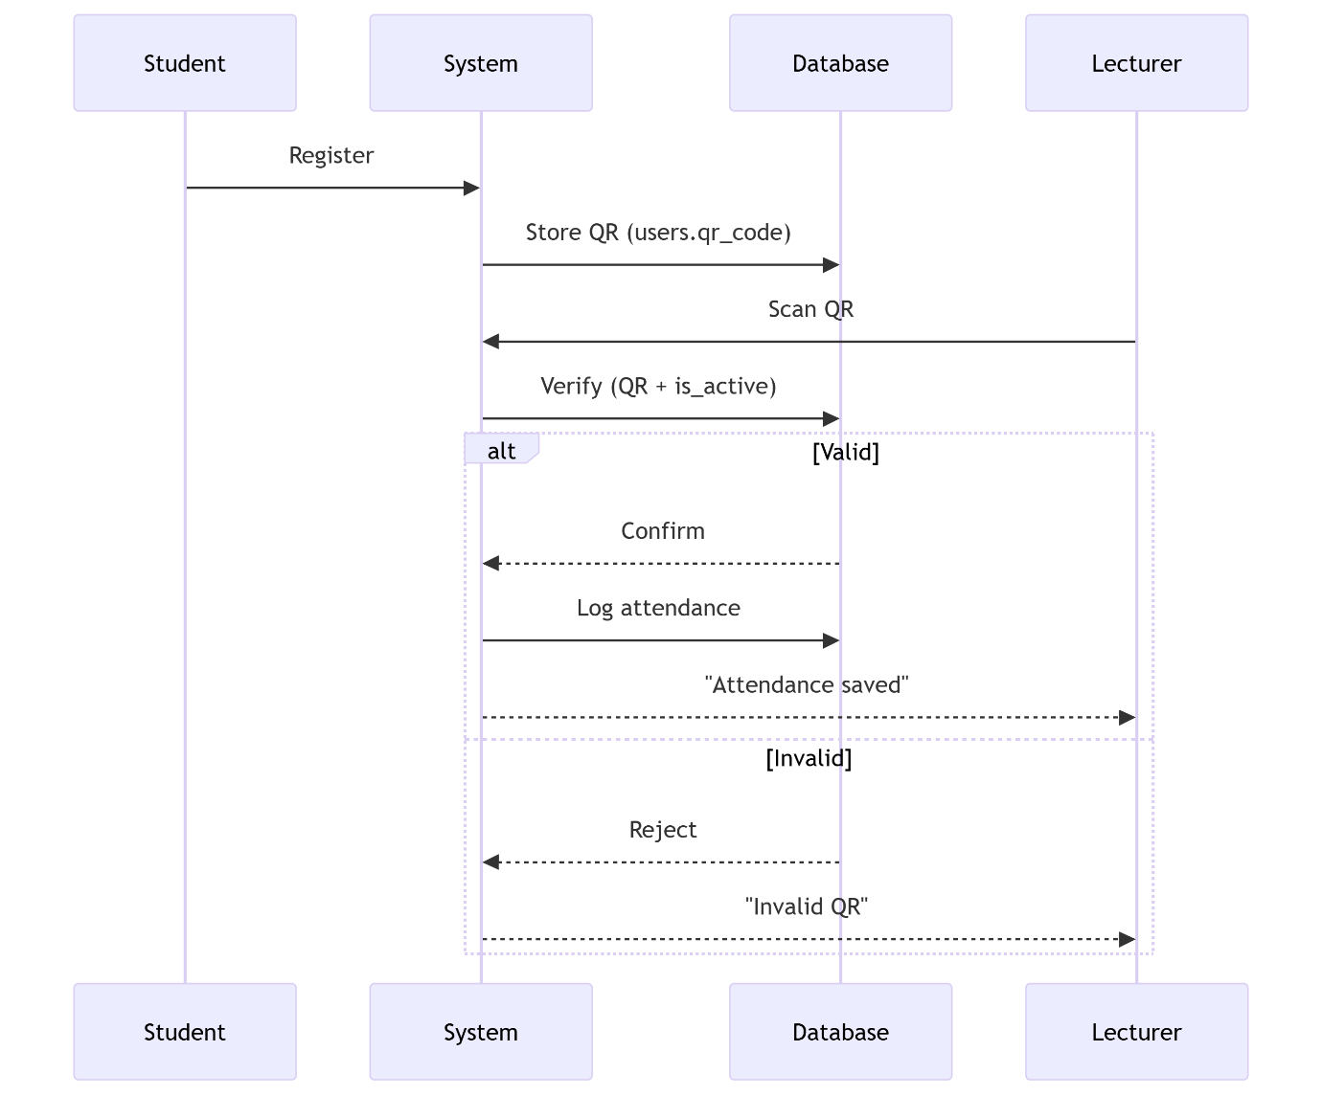

1. **Database Schema**

Collections

* 1. Users

{

_id: ObjectId,

username: String,

password: String, // Bcrypt-hashed

email: String,

role: "admin"|"lecturer"|"student",

courses_enrolled: [ObjectId] // For students

}

* 1. Courses

{

_id: ObjectId,

name: String,

code: String,

lecturer_id: ObjectId,

schedule: { day: String, time: String }

}

* 1. Attendance

{

_id: ObjectId,

course_id: ObjectId,

student_id: ObjectId,

qr_code_id: ObjectId,

timestamp: Date,

status: "present"|"absent"

}

* 1. QR Codes

{

_id: ObjectId,

course_id: ObjectId,

expiry: Date, // 15-minute validity

is_active: Boolean

}

1. **Class Diagram**

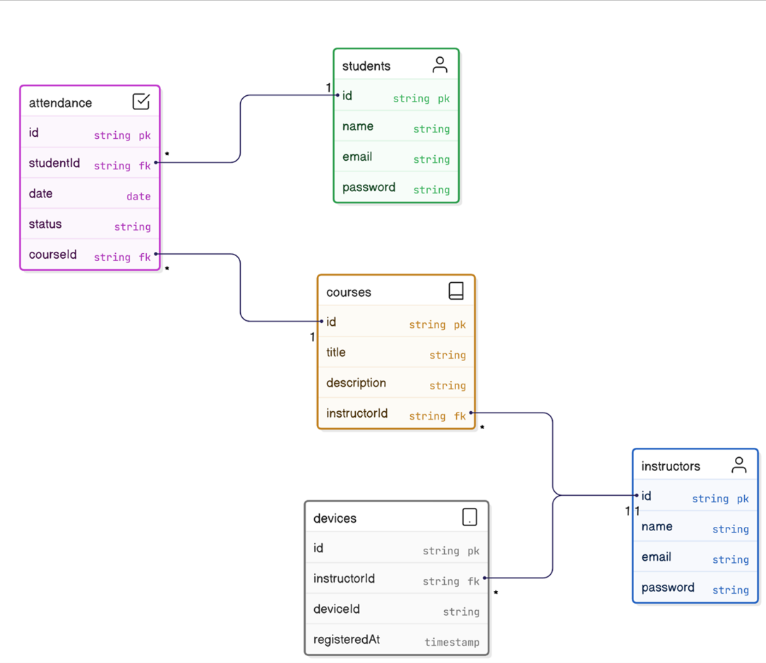

1. **Security Implementation**

|  |  |
| --- | --- |
| Feature | Implementation |
| QR Code Security | 15-minute expiry, one-time use |
| Data Encryption | TLS 1.3, MongoDB field-level encryption |
| API Protection | Rate limiting (100 reqs/min) |
| Input Validation | Sanitize all user inputs (XSS prevention) |

1. **Conclusion**

Project-X replaces manual attendance with a secure, QR-code-driven workflow:

* **Admins** oversees system integrity.
* **Lecturers** generate session-specific QR codes in 2 clicks.
* **Students** scan codes for instant check-ins.

Built with React Native and Node.js, the system prioritizes:  
✅ **Efficiency** – No manual roll calls.  
✅ **Security** – JWT, encrypted data, and time-bound QR codes.  
✅ **Scalability** – Cloud-native MongoDB Atlas backend.

**Appendices**

* **Risk Log**: Mitigation plans for QR code spoofing.
* **Test Cases**: Sample Jest unit tests for QR validation.